**Assessment 2: Dependency analysis**

Analyze dependencies in a systems environment

**Task 1:** Draw a dependency graph for a university course registration system

**Task 2:** Suggest modularization strategies to manage dependencies

**Deliverables: Dependency Graphs & a modularization strategy**

Answers:

**Task 1:**

How It Works

**Breakdown of Dependencies**

1. Student logs in → via Login System (using Student ID and Computer Number).
2. Selects courses → from Course Selection Module.
3. Approval required → via HOD/Assistant Dean in Approval System.
4. Fees Checked → in Finance Module.
5. Payment Processed → through ZANACO Payment System.
6. Student ID Issued → after payment confirmation.
7. Record Kept → in Student Affairs Unit.
8. Registration Complete!

**DEPENDENCY GRAPH FOR UNZA COURSE REGISTRATION SYSTEM**

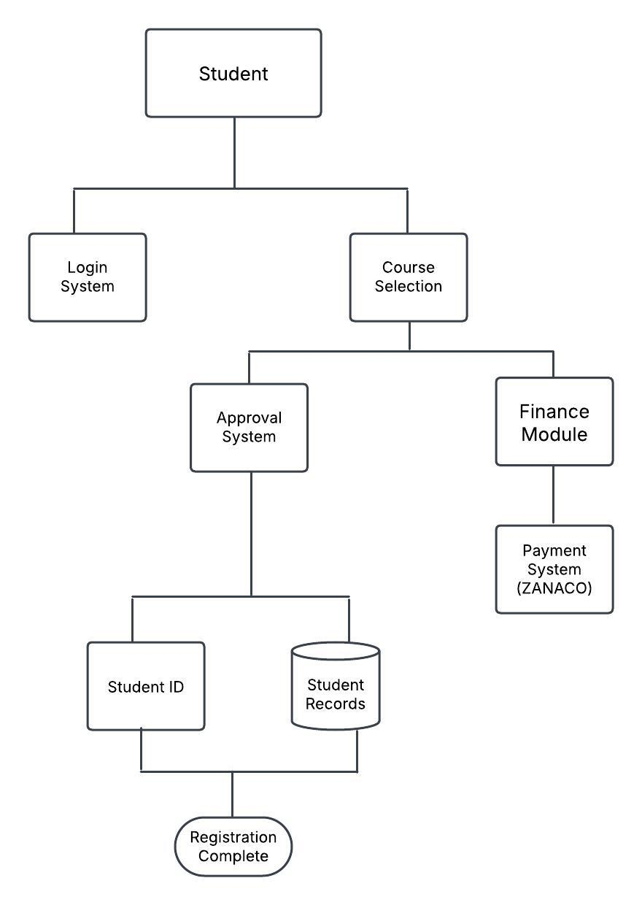

**Task 2:**

**Modularization Strategy**

We divide the system into four core modules:

1. **User Authentication Module →** Manages login and security.
2. **Course Registration Module →** Handles course selection & approvals.
3. **Finance & Payment Module** → Manages tuition calculation & payments**.**
4. **Student Services Module →** Issues student ID & keeps student records.

-This reduces interdependencies, making the system scalable and easy to maintain.